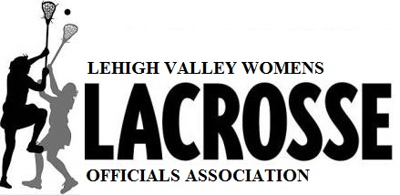

IS SEEKING CANDIDATES WHO ARE AGES 14 and OLDER
AND ARE INTERESTED IN
BECOMING A GIRL’S YOUTH LACROSSE OFFICIAL
REGISTRATION FORMS FOR TRAINING ARE NOW AVAILABLE @ www.leaguelineup.com/lvwloa
• TRAINING SESSIONS WILL BE CONDUCTED VIRTUALLY ON ZOOM
• THERE WILL BE FIVE-90 MIN. VIRTUAL SESSIONS AND THREE ON-FIELD TRAININGS
• IN-SEASON GAME ASSIGNMENTS WILL BE FLEXIBLE FOR HIGH SCHOOL PLAYERS TO ACCOMODATE PRACTICE AND GAME SCHEDULES
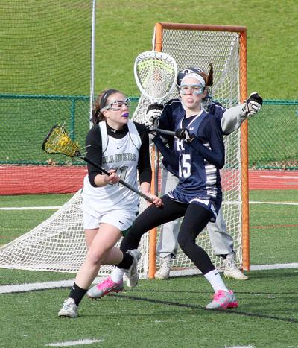
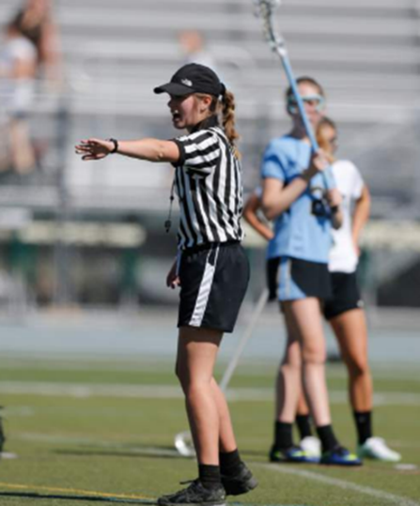
• FOR MORE INFORMATION EMAIL steideld@ptd.net or 610-762-8011

